EXP NO : 3 System Calls: Fork, Exit, Getpid, Wait, Close
C PROGRAM : fork()
#include <stdio.h>
#include <stdlib.h>
#include <unistd.h>
#include <sys/wait.h>
int main()
{
pid_t pid;
pid = fork();
if(pid < 0)
{
printf("Fork Failed\n");
exit(1);
}
else if(pid == 0)
{
printf("\nCHILD PROCESS");
printf("\nChild PID : %d", getpid());
printf("\nParent PID : %d\n", getppid());
exit(0);
}
else
{
wait(NULL);

printf("\nPARENT PROCESS");
printf("\nParent PID : %d", getpid());
printf("\nParent's Parent PID : %d\n", getppid());
}
return 0;
}
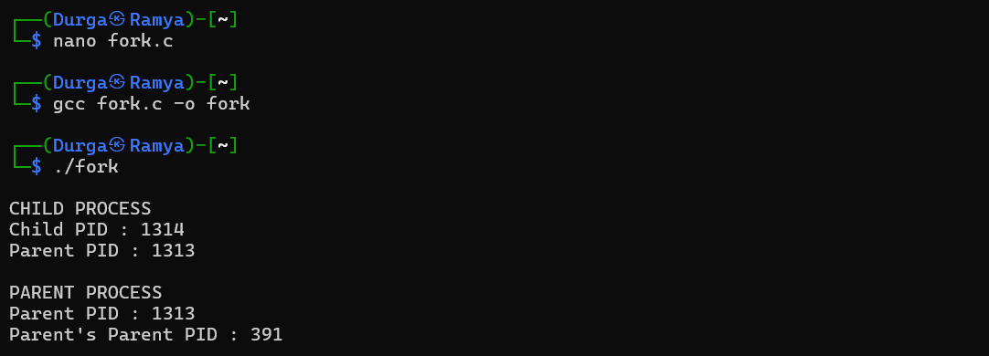
SHELL SCRIPT :
#!/bin/bash
echo "Parent Process ID : $$"
(
echo "Child Process ID : $$"
echo "Parent Process ID : $PPID"
exit 0
) &
wait
echo "Child Process Completed"
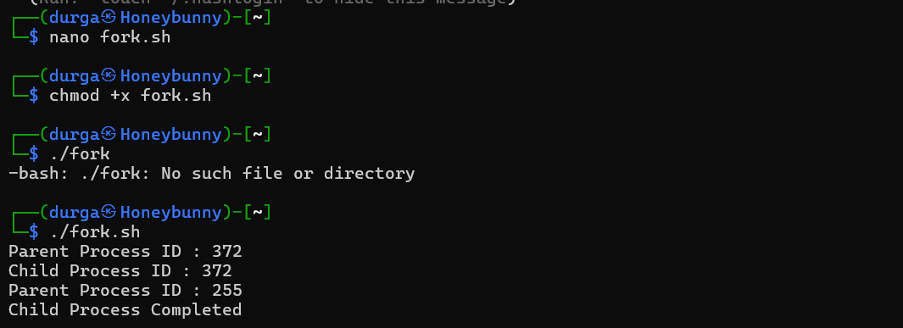

C PROGRAM : wait()
#include <stdio.h>
#include <unistd.h>
#include <sys/wait.h>
int main()
{
pid_t pid;
pid = fork();
if(pid == 0)
{
printf("Child Process Running\n");
sleep(5);
printf("Child Process Completed\n");
}
else
{
wait(NULL);
printf("Parent Resumes Execution\n");
}
return 0;
}
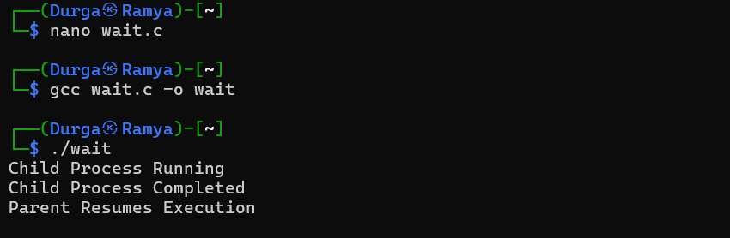
SHELL SCRIPT :
#!/bin/bash
(echo "Child Process Running"
sleep 5
echo "Child Process Completed"
) &
Wait
echo "Parent Resumes Execution"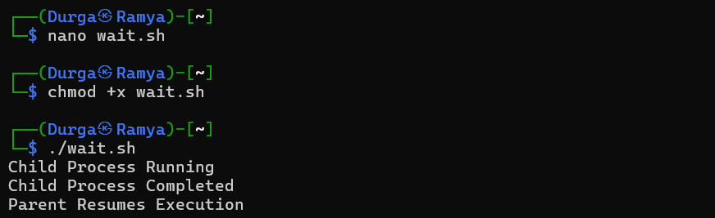

C PROGRAM : CLOSE
#include <stdio.h>
#include <fcntl.h>
#include <unistd.h>

int main()
{
int fd;
fd = open("sample.txt", O_RDONLY);
if(fd < 0)
{
printf("File Opening Failed\n");
return 1;
}
printf("File Opened Successfully\n");
close(fd);
printf("File Closed Successfully\n");
return 0;
}
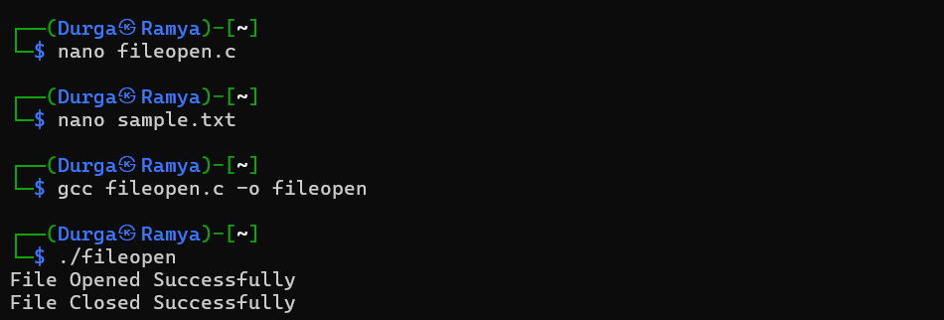

SHELL SCRIPTING :
#!/bin/bash
exec 3< sample.txt
echo "File Opened Successfully"
exec 3<&-
echo "File Closed Successfull

